|  |  |  |  |
| --- | --- | --- | --- |
| **Name of Student: NINAD AVINASH PATIL** | | | |
| **Roll No: 33** | | **Lab Practical Number: 3(C)2** | |
| **Title of Lab Practical:**  **Use dataset**  **Create the table with the given fields.**  **FIELD NAME DATA TYPE**  **EmpNo number**  **EmpName varchar**  **EmpSal number**  **EmpJob varchar**  **EmpDeptNo number**  **For the given table design a web page to display the employee information from table to grid control. Use LINQ TO ADO.NET** | | | |
| **DOP: 06/04/2021** | | **DOS: 10/04/2021** | |
| **CO Mapped: CO1** | **PO Mapped: PO3, PO5, PO7,**  **PO12, PSO1, PSO2** | **Faculty Signature:** | **Marks:** |

**Practical No 3(C)1**

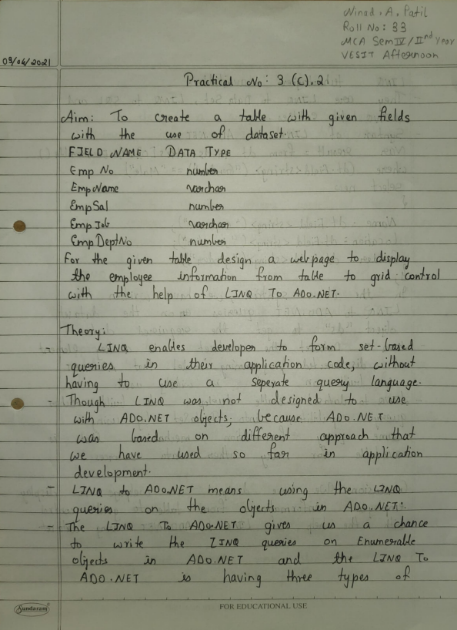

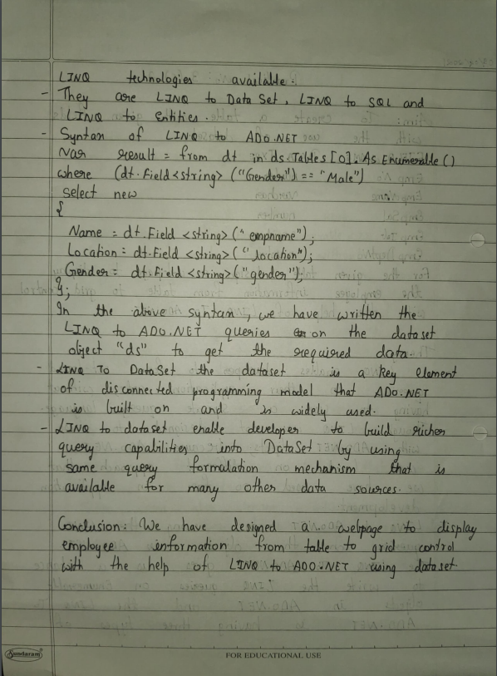

**Code:**

**WebForm2.aspx.cs**

using System;

using System.Collections.Generic;

using System.Linq;

using System.Web;

using System.Web.UI;

using System.Web.UI.WebControls;

namespace P3C

{

public partial class WebForm2 : System.Web.UI.Page

{

protected void Page_Load(object sender, EventArgs e)

{

DataClasses1DataContext dc = new DataClasses1DataContext();

var selectquery = from a in dc.GetTable<EMP>() select a;

GridView1.DataSource = selectquery;

GridView1.DataBind();

}

protected void GridView1_SelectedIndexChanged(object sender, EventArgs e)

{

}

}

}

**WebForm2.aspx**

<%@ Page Language="C#" AutoEventWireup="true" CodeBehind="WebForm2.aspx.cs" Inherits="P3C.WebForm2" %>

<!DOCTYPE html PUBLIC "-//W3C//DTD XHTML 1.0 Transitional//EN" "http://www.w3.org/TR/xhtml1/DTD/xhtml1-transitional.dtd">

<html xmlns="http://www.w3.org/1999/xhtml">

<head runat="server">

<title></title>

</head>

<body>

<form id="form1" runat="server">

<div>

Displaying Details Of Employees Using LINQ To ADO.NET<br />

</div>

<br />

<asp:GridView ID="GridView1" runat="server"

onselectedindexchanged="GridView1_SelectedIndexChanged">

</asp:GridView>

</form>

</body>

</html>

**Output:**

